Avoid

1.0.

Contents

Overview 3

How to Reskin 4

How to open the Project 6

How to Edit Project Settings 8

How to Change Build Target 10

How to Change Background Colour 11

How to Change the Players Speed 12

How to Change the Delay Between Point Spawns 13

How to Change the Enemy Spawn Rate 14

How to Change the Enemy Spawn Rate 15

How to Configure “Rate Me” Button (Android and IOS Only) 17

How to Configure Leaderboard Support (Android Only) 19

# Overview

Gameplay overview: single screen game. Swipe your finger across the screen to navigate and avoid the obstacles and any enemies following you. Gameplay tip: lure the enemies into oncoming projectiles to destroy them.

Developed using Unity 5.3.5 (newest version at time of release), which means it can be released on up to ten platforms (including IOS, Android, and Windows mobile platforms).

Other features:

* Endless gameplay.
* Easy to reskin, just drag and drop new files over old (outline of the process is included in this guide).
* Game has persistent saves: your score is stored between plays and updated to a global leaderboard (Android only).

Full documentation for the Unity engine can be found at: <http://docs.unity3d.com/Manual/index.html>

Code documentation has been included in a separate file.

# How to Reskin

**Sprites are located in: Unity Project/Avoid/Assets/Avoid/Sprites/**

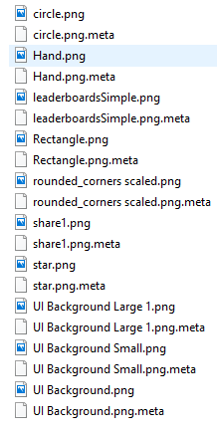

**Audio clips are located in: Unity Project/Avoid/Assets/Avoid/Audio/**

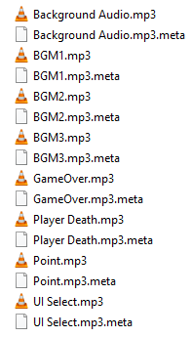

To change the sprites/audio:

1) Ensure project is not open in Unity.

2) Find the sprite or audio clip you would like to replace in a file explorer. Use the above paths as reference.

3) Copy your file into the folder. Important: ensure your file has the same name as the one you would like to replace.

4) When asked if you would like to replace the file, select Yes. The file will be overwritten.

You should ignore the .meta files. These are automatically generated by Unity. Ensure that your sprites have the same dimensions as the originals, otherwise objects may become distorted in the game and require you to manually scale objects in Unity.

# How to open the Project

The project should open in newer versions of Unity but for full compatibility it is recommended you use version 5.3.5.

1. Download and install Unity 5.3.5. from: <https://unity3d.com/get-unity/download/archive>
2. Click on the “Open” link (located at the top of the window and shows in the image below) and navigate to the Unity Project/Avoid folder.



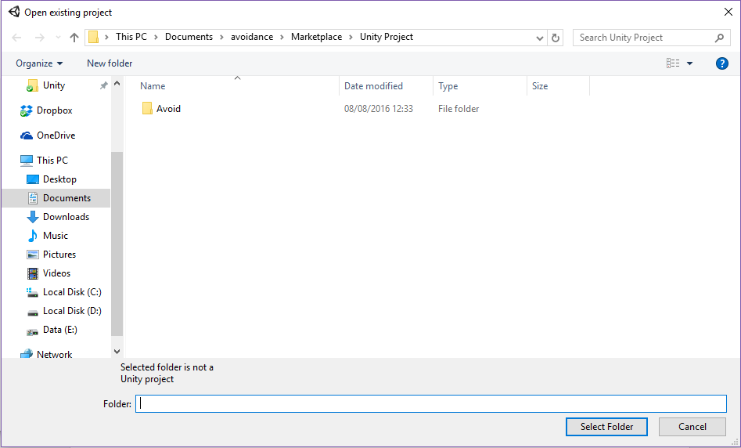

1. You may see the window below. If you do, press Continue.

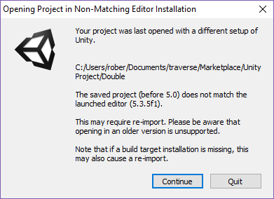

1. Once open in Unity, in the Project window, navigate to the Scenes folder. Double-click on the “Game Scene” to edit it.

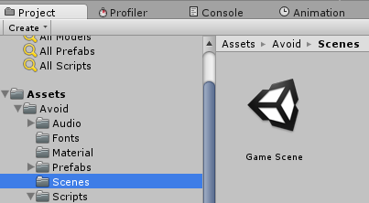

# How to Edit Project Settings

To publish to a store, you will need to:

* Provide a unique identifier.
* Set your company name
* Set the product name.

These settings can be changed within unity itself by following the instructions below.

1. Go to Edit -> Project Settings -> Player.

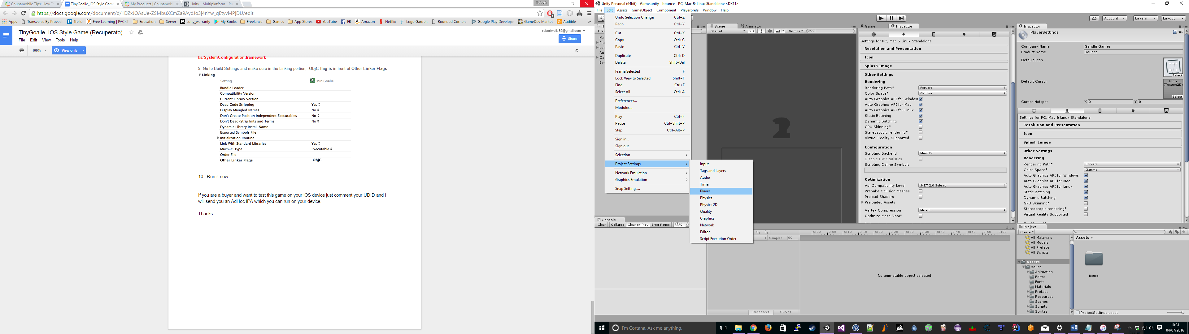

1. The Company Name and Product names are now at the top of the Inspector window.

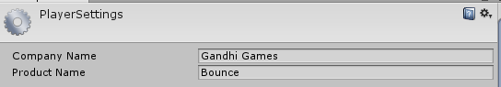

1. Under the Other Settings heading you can set the bundle identifier.

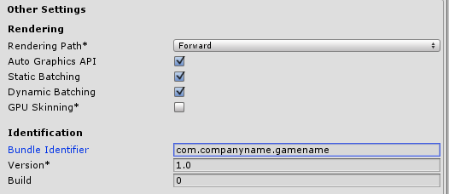

# How to Change Build Target

As stated earlier, using Unity you can publish to a number of different platforms. To target a different platform:

1. Go to File -> Build Settings.

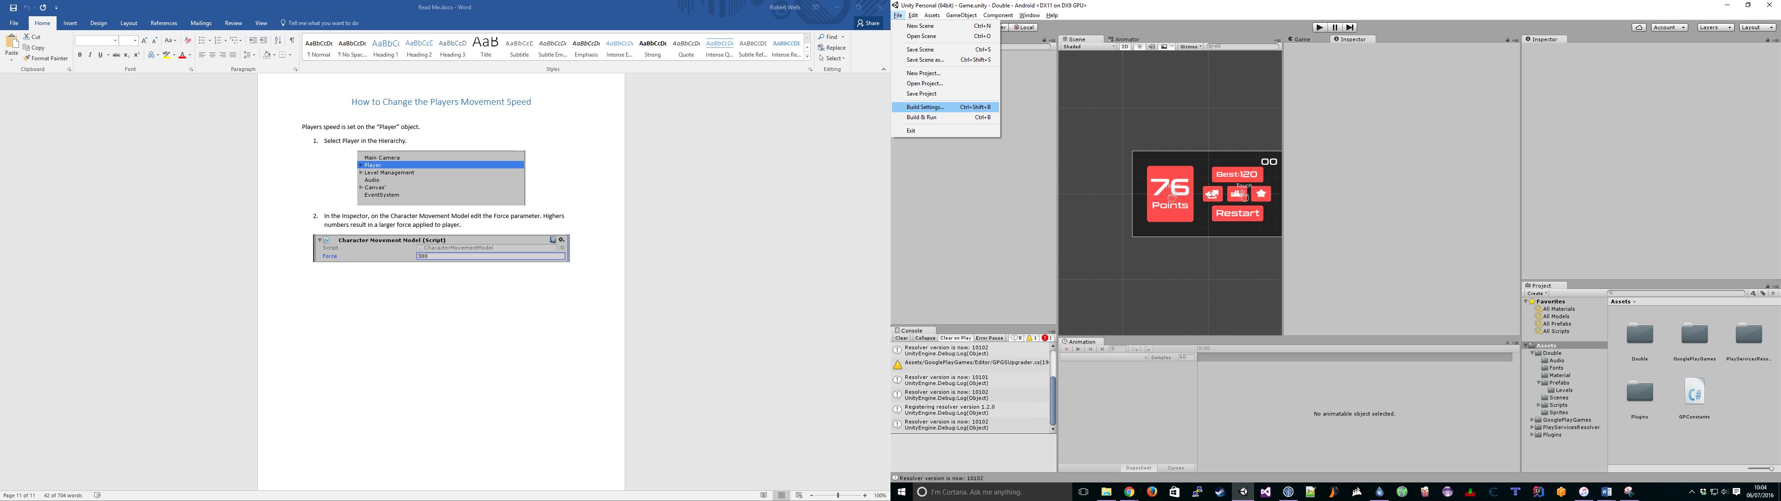

1. Click on a different Platform and the click Switch Platform (bottom left of window).

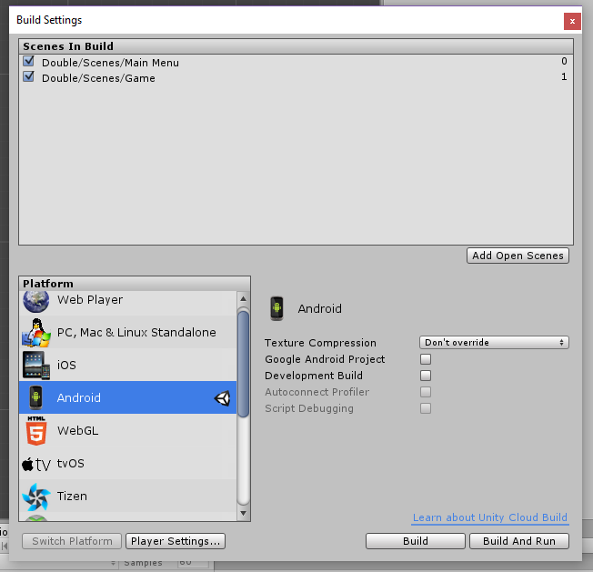

# How to Change Background Colour

The background colour is set on the “Background” object.

1. Select Background in the Hierarchy.

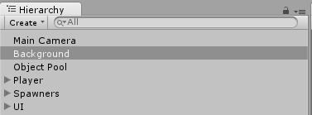

1. In the inspector, click on the Color on the Sprite Renderer to edit. This will change the background colour of the game.

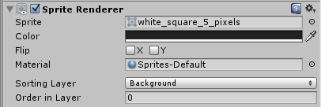

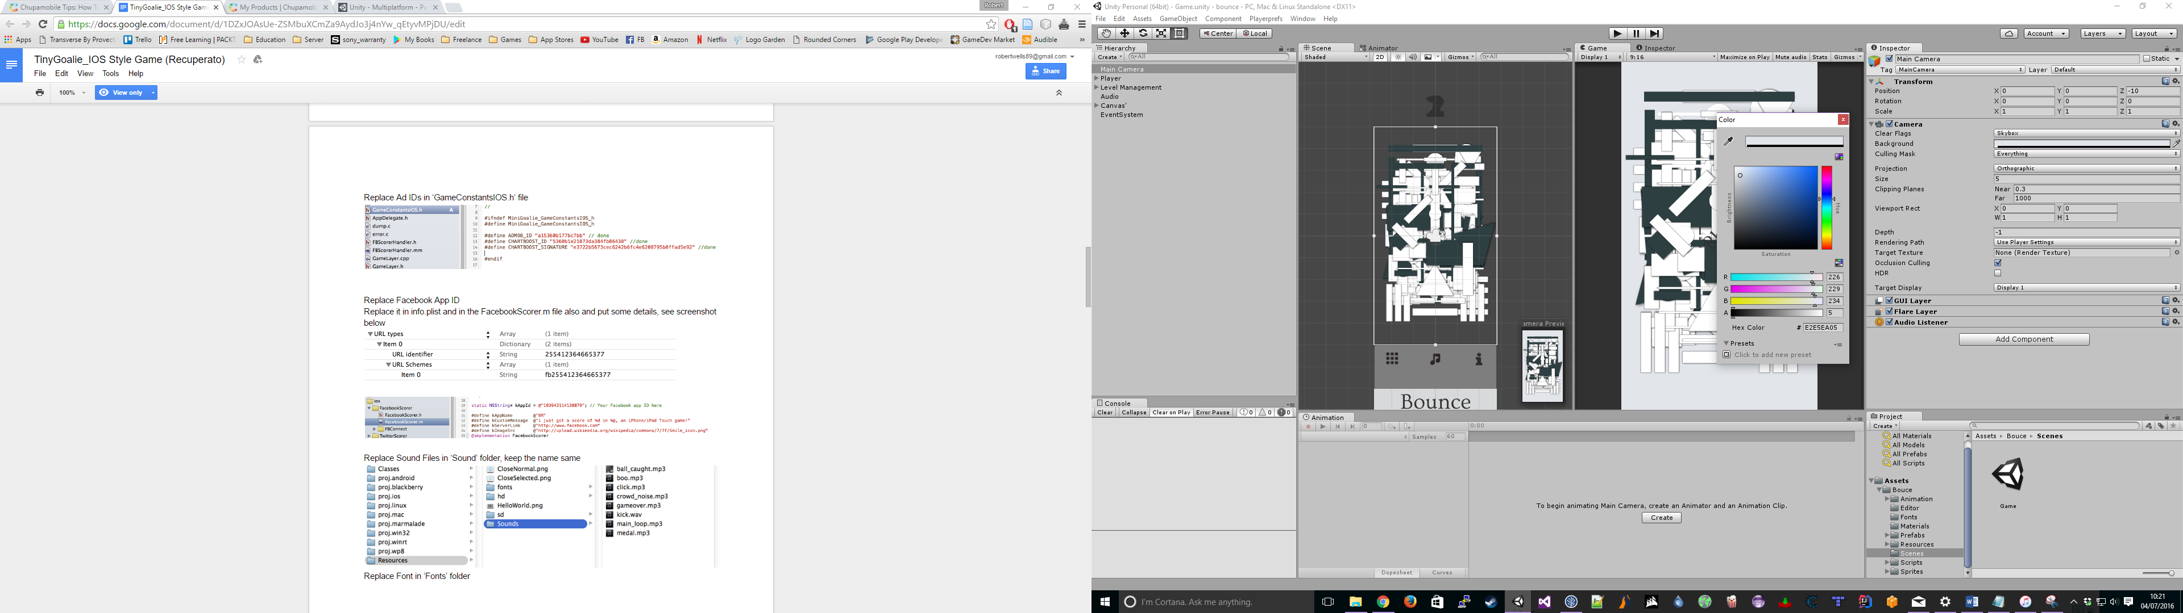

# How to Change the Players Speed

The players speed is set on the Player object.

1. Select Player in the Hierarchy.

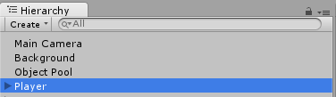

1. Edit “Move Units Per Second” in the inspector. Higher numbers will result in quicker movement.

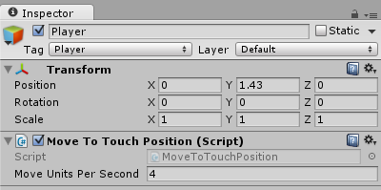

# How to Change the Delay Between Point Spawns

The time between point spawns is set on the Points Spawner object.

1. Select Points Spawner in Hierarchy.

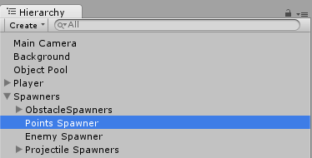

1. Edit the “Delay Between Spawn”. Lower number results in less of a delay between points being spawned.

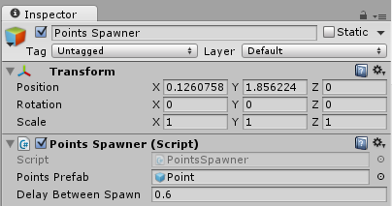

# How to Change the Enemy Spawn Rate

The enemy spawn rate is set on the Enemy Spawner object.

1. Select the Enemy Spawner object in the Hierarchy.

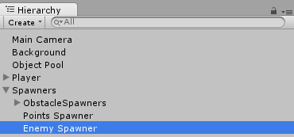

1. Edit the “Min Max Spawn Delay”. A random time is selected between these two numbers.

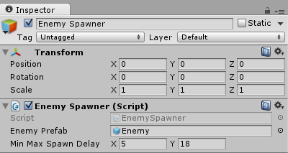

# How to Change the Enemy Spawn Rate

There are two types of projectile spawners, each with their own object. “Projectile Spawner Towards Player” shoots a single projectile towards the player, and “Projectile Spawner 360” shoots a number of projectiles in a 360 arc around itself.

To edit the Projectile Spawner Towards Player:

1. Select Projectile Spawner Towards Player in the Hierarchy.

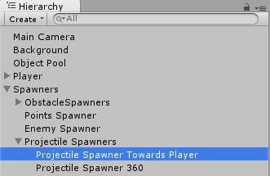

1. Edit “Min Max Time Between Spawns”, “Min Max Time Initial Delay” (the delay at the beginning of the game), and “Chance to Spawn” (0 = will never spawn, 1 = will always spawn) in the inspector.

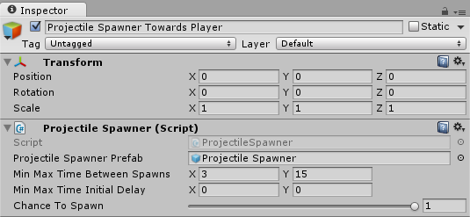

To edit the Projectile Spawner 360:

1. Select Projectile Spawner 360 in the Hierarchy.

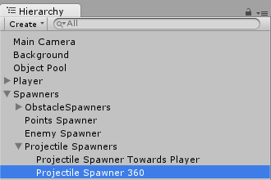

1. Edit “Min Max Time Between Spawns”, “Min Max Time Initial Delay” (the delay at the beginning of the game), and “Chance to Spawn” (0 = will never spawn, 1 = will always spawn) in the inspector.

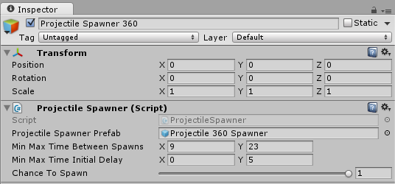

# How to Configure “Rate Me” Button (Android and IOS Only)

The Rate button is shown on the Pause and Gameover menus. It takes the user to the store page for the game. You need to configure the link to your store page manually by following the below steps.

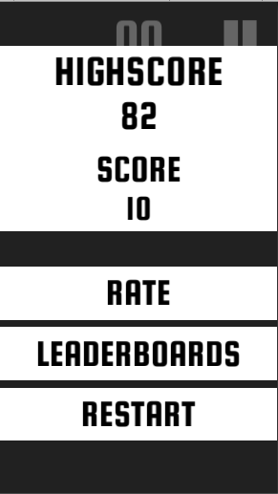

1. Navigate to the Assets/Avoid/Scripts/Social folder and double-click on the ShareAndRate class to open it.

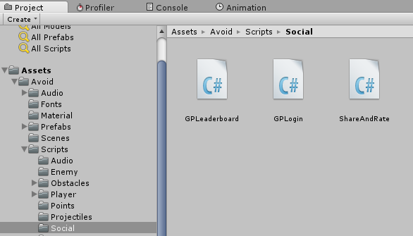

1. Edit the ANDROID_APP_ID and IOS_APP_ID at the top of the class with your details.



1. Save and close the class. The links will not work correctly until you have uploaded the game to the relevant store.

The Android app id will be the same as the bundle identifier you set during the “How to Edit Project Settings”. The iOS app id is provided by Apple during the upload process.

# How to Configure Leaderboard Support (Android Only)

The leaderboard plugin was downloaded from: <http://github.com/playgameservices/play-games-plugin-for-unity>.

I did not develop this plugin; it is the official first-party plugin for adding Google Play support to your game. As such, I cannot provide technical support for problems with this plugin.

The instructions below can also be found in the link provided.

1. Create your project in the Google Play Developer Console (instructions for this can be found on the internet and is outside the scope of this guide).
2. Copy the game resources from the console.

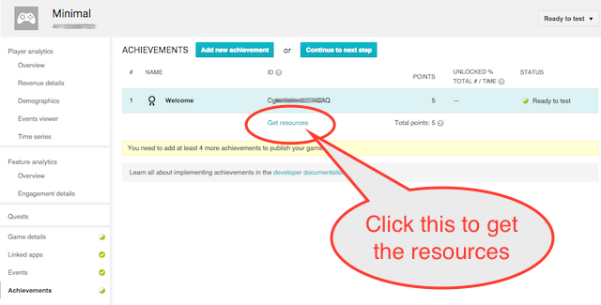

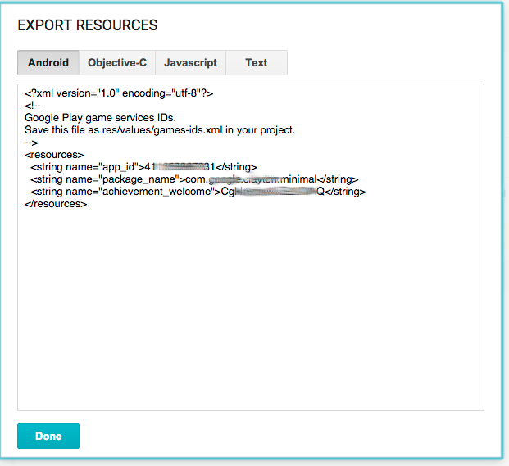

1. Select and copy all the contents of the resources window.
2. Back in Unity, open the setup dialog Window -> Google Play Games -> Setup... -> Android Setup

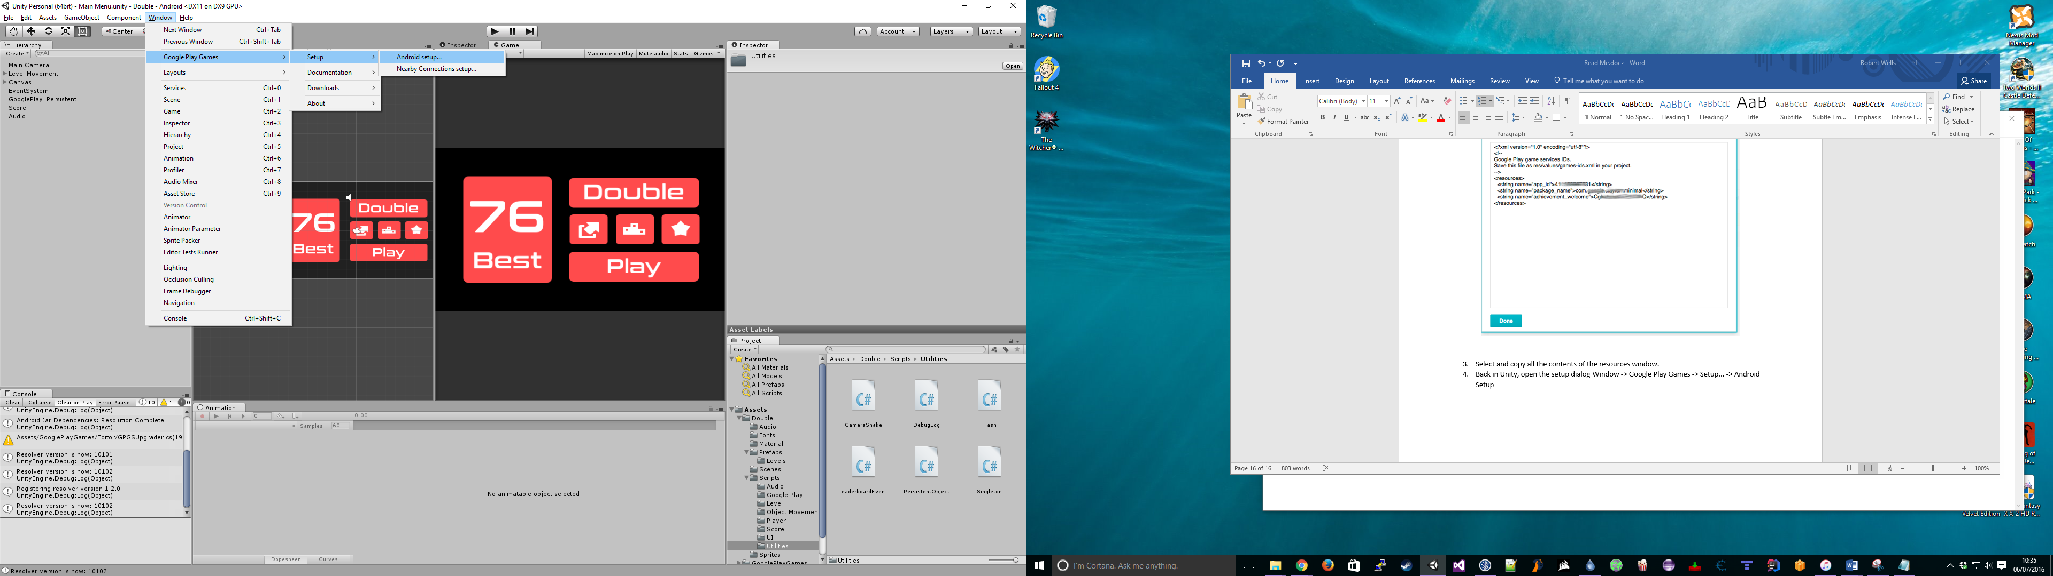

1. Enter the following details:

**Enter the directory to save constants** - Enter the folder for the constants file.

**Constants class name** - this is the name of the C# class to create, including namespace.

**Resources Definition** - paste the resource data from the Play Games console here.

**Web client ID (Optional)** - this is the client ID of the linked web app. It is only needed if you have a web based back-end for your game, need an access token for the player to make other, non-game API calls, or need to access the email address of the player.

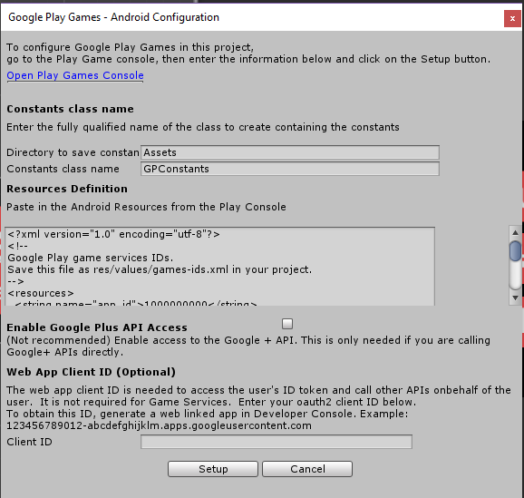

1. Click on Setup. The setup process will configure your game with the client id and generate a C# class that contains constants for each of your resources.